Join us at Ford Street for our Lenten Study:
“Entering the Passion of Jesus”
Sundays at 3:00 pm Feb 18-Mar 24

_______________________________________________________________
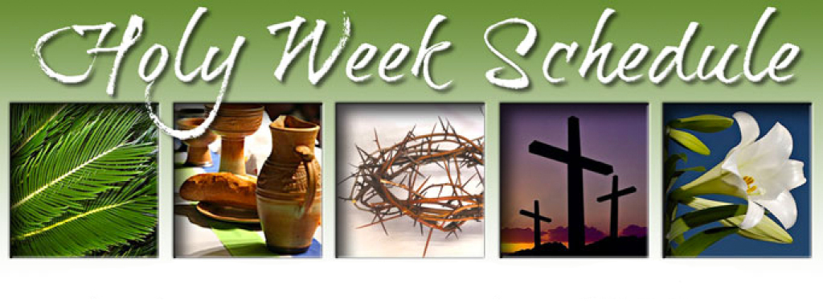

Maundy Thursday Worship: March 28, 7:00 pm
Good Friday Worship: March 29, 7:00 pm
Easter Sunday:
7:30 am--Sunrise worship,
8:30 am--Pitch-In Breakfast,
9:30 am--Easter Celebration

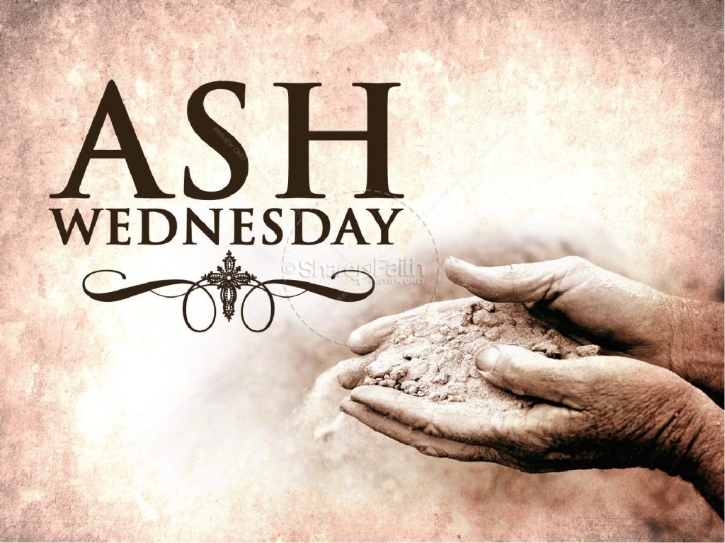

PO Box 626 925 Ford St. Lapel, IN 46051 ph: 765-534-3314
www.fordstreetchurch.com
Pastor Jill Moffett: jill.L.moffett@gmail.com
Ash WednesdayWorship
February 14, 2024 7:00 pm

GATHERING MUSIC Linda Hormell

WELCOME Pastor Jill

*OPENING HYMN “Lord, Who Throughout These Forty Days” #269 All

*CALL TO WORSHIP Kyndra Springer

Leader: Even as we enter the wilderness of Lent,

People: We rest in the shelter of the Most High;

Leader: We abide in the shadow of the Almighty.

People: We find refuge under the wings of our Holy Parent.

Leader: We trust that the angels of God,
People: the words of God,
Leader: the people of God,
People: the hands of God
Leader: Will somehow bear us up.
People: And so we come to call on God who has promised to answer.

*Opening Prayer Kyndra Springer
In these forty days, O Lord, You lead us into the desert of repentance, that in this pilgrimage of prayer we might learn to be your people once more. In fasting and service You bring us back to your heart. You open our eyes to your presence in the world and you free our hands to lead others to the radiant splendor of your mercy. Be with us in these journey days, for without you we are lost and will perish. To you alone be dominion and glory, forever and ever. Amen.

Offering/Offertory
*Doxology #95
Prayer Over Offering Pastor Jill
Scripture Lesson 1 Psalm 51:1-12 Kyndra Springer
Hymn “Just as I Am, Without One Plea” #357, v. 1, 2, 4, 5 All
Pastoral Prayer/Lord’s Prayer Pastor Jill
Scripture Lesson 2 2 Corinthians 5:20 - 6:10 Pastor Jill

Sermon “Paradox” Pastor Jill

Invitation to Observe a Holy Lent Pastor Jill

Dear brothers and sisters in Christ: the early Christians observed with great devotion the days of our Lord’s passion and resurrection, and it became the custom of the Church that before the Easter celebration there should be a forty-day season of spiritual preparation. I invite you, therefore, to observe a holy Lent: by self-examination and repentance; by prayer, fasting, and self-denial; and by reading and meditating on God’s Holy Word. To make a right beginning of repentance, and ask a mark of our mortal nature, let us now be silent before our Creator and Redeemer.
Moment of Silence
Thanksgiving Over the Ashes Pastor Jill
Almighty God, you have created us out of the dust of the earth. Grant that these ashes may be to us a sign of our mortality and penitence, so that we may remember that only by your gracious gift are we given everlasting life; through Jesus Christ our Savior. Amen.
Imposition of Ashes
*Hymn “Rock of Ages, Cleft for Me” 361, v. 1-3 All
Sending Forth Pastor Jill

Scripture readings:
Psalm 51:1-12
51:1 Have mercy on me, O God, according to your steadfast love; according to your abundant mercy blot out my transgressions.

51:2 Wash me thoroughly from my iniquity, and cleanse me from my sin.

51:3 For I know my transgressions, and my sin is ever before me.

51:4 Against you, you alone, have I sinned, and done what is evil in your sight, so that you are justified in your sentence and blameless when you pass judgment.

51:5 Indeed, I was born guilty, a sinner when my mother conceived me.

51:6 You desire truth in the inward being; therefore teach me wisdom in my secret heart.

51:7 Purge me with hyssop, and I shall be clean; wash me, and I shall be whiter than snow.

51:8 Let me hear joy and gladness; let the bones that you have crushed rejoice.

51:9 Hide your face from my sins, and blot out all my iniquities.

51:10 Create in me a clean heart, O God, and put a new and right spirit within me.

51:11 Do not cast me away from your presence, and do not take your holy spirit from me.

51:12 Restore to me the joy of your salvation, and sustain in me a willing spirit.

2 Corinthians 5:20-6:10
20 So we are ambassadors who represent Christ. God is negotiating with you through us. We beg you as Christ’s representatives, “Be reconciled to God!” 21 God caused the one who didn’t know sin to be sin for our sake so that through him we could become the righteousness of God. 6 1 Since we work together with him, we are also begging you not to receive the grace of God in vain. 2 He says, I listened to you at the right time, and I helped you on the day of salvation. Look, now is the right time! Look, now is the day of salvation!
3 We don’t give anyone any reason to be offended about anything so that our ministry won’t be criticized. 4 Instead, we commend ourselves as ministers of God in every way. We did this with our great endurance through problems, disasters, and stressful situations. 5 We went through beatings, imprisonments, and riots. We experienced hard work, sleepless nights, and hunger. 6 We displayed purity, knowledge, patience, and generosity. We served with the Holy Spirit, genuine love, 7 telling the truth, and God’s power. We carried the weapons of righteousness in our right hand and our left hand. 8 We were treated with honor and dishonor and with verbal abuse and good evaluation. We were seen as both fake and real, 9 as unknown and well known, as dying—and look, we are alive! We were seen as punished but not killed, 10 as going through pain but always happy, as poor but making many rich, and as having nothing but owning everything.

Join us for…
Maundy Thursday Worship: March 28, 7:00 pm
Good Friday Worship: March 29, 7:00 pm
Lenten Study: Entering the Passion of Jesus, Sundays at 3:00 pm Feb. 18-March 24
Easter Sunday, 7:30 am Sunrise worship, 8:30 am Breakfast, 9:30 am Easter Celebration

