Please lift in prayers of peace and healing: Our Coffee Shop Ministry, Victims of natural disasters, Law Enforcement Officers, Peace in the world, Our Town, The Curless Family, The Abshire Family, The Wooten Family, those recovering from illness, Janet Galliher, Jim Upton, Melissa Bremer, Charlotte Hampton (tonsillectomy), Ernie Presser’s sister Margaret, Sandy Cheshier, Earlene Arnold, Jerry Johnson, Joy Jennings, Nancy Tarvin, Teresa Bond, Allison Sheller, Alan Stacy, Peggy Campbell, Emma Johnson, Patty Cook, Barb Smith, Sharon Beamer, Amanda Jackson, Marissa Farris, Dominik DeGuzman, Kim Gunn, Tracy Thompson, Jennifer McCallen, David Hormell, Bob Taber, Susie Moore, Gary Gunn, Dennis Humphrey, Terry Rich, Susie Cecil, Ruth Leakey, Steve Reddick, Marshall Everett, Danny Barmes, Barbara Mott, LaDonna Rose, Devon Blasius, Lynne Fisher, Allison Sheller, Alice Morris, Owen Coomer, Wilbur Eiler, Cole Whistler, Joe Denger, Bill Pape, Carolyn Bollman, Susie Johnson, Judy Davis, Wayne Duckworth, Beth Borton, Travis (Kim Gunn’s brother), Teresa Johnson, Truman Miller, Jack & Jackie Howell, Don Shupe, Betty Bunnell, Mickey Mills, Gordon Leavell, Rachel Forrer, Abby West, Pat Stephenson, Darion Bond, Kenny Russell, Terri Hill, Emma Johnson, Sue Snyder, Scott Kirby, Donna Young, Steve Stoekert, Ted Breen, Peggy Nunley, Lisa Bernard, Bobby Kean, Lu Wade, Brylan Cripe, Todd Castor, Lavonne Hobbs, Sarah Wright, Angela & Orbie Simmerman Dixon, Maryhelen Smith, Brandy Baker, Bob Hatfield, Brent White, Colin Gillespie, Chloe Forrer, Margaret Baldwin, Max Clark, James Boe, Patty Carter, Bill Goodner, Levi Chisholm
_____________________________________________________________________________________________________________________________________________________________________

This week’s activities:
Sunday School Room #’s: PreK-3 Rm 203, Grades 4-8 Rm 209, Grades 9-12 and up Rm 202; Recap in Resource Room; Cornerstone Class in Conference Room;

Today: Worship @ 9:30 am; 10:45 am Sunday School; 5:00 Youth

Monday: Crochet Club @ 6:30 pm

Tuesday: 6:30 pm--Women’s Study Group @ Pax Verum

Wednesday: Ashes to go in Coffee Shop from 9 am- 12 pm; Senior Lunch! (Chicken Alfredo, Veggies, Roll & Dessert), Ash Wednesday Service @ 7 pm

Thursday: Wacky Weavers @ 9 am

Friday: “5th Quarter” after LHS Basketball Game

Saturday Feb 17: “Random Acts of Kindness” Day Be the hands and feet of Jesus!

*The Men’s Lenten Breakfast Series begins Saturday February 17th. The entire schedule is available in convenient pocket form on the Resource Table. Ford Street and Trinity will host the breakfast on Feb 24th here at Ford Street featuring Jimmie Howell as the guest speaker.

Attendance & Offering for 02/04/24

Worship—84 Sunday School--21

General Offering………………… $3622.00 Community Support………………..32.00

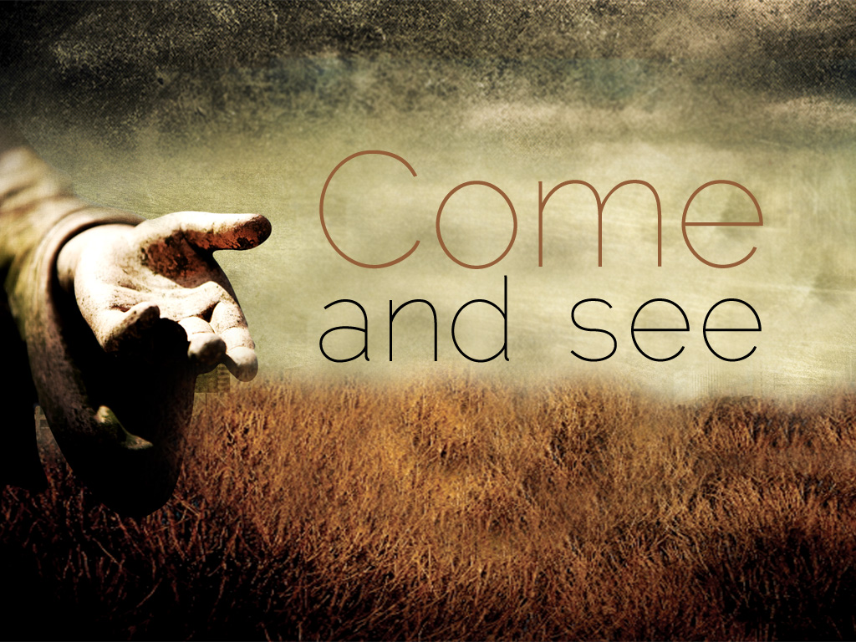

PO Box 626 925 Ford St. Lapel, IN 46051 ph: 765-534-3314
www.fordstreetchurch.com
Pastor Jill Moffett: jill.L.moffett@gmail.com
Order of Worship
February 11, 2024 9:30 am

GATHERING MUSIC Linda Hormell & Cathy Boone

WELCOME Pastor Jill

BIRTHDAYS & ANNIVERSARIES Jim Hormell

The flowers today are dedicated by Amy Egly in honor of her son, Dominik DeGuzman. Thank you for sharing this with us this morning!

ANNOUNCEMENTS (Please sign and pass the attendance pads.) Jim Hormell

*OPENING HYMN “Jesus Calls Us” #398

*CALL TO WORSHIP Amy Egly

One: Jesus calls us to come and see…
All: …the radical welcome he offers to all.
One: Jesus calls us to come and see…
All: …the ways in which he can change our lives for the better.
One: Jesus calls us to come and see…
All: …that we will be made whole, renewed, and transformed by the grace of God.
*Gathering Prayer:

God of grace and welcome, you call us out of our comfort zones and routines and into a life of following You. We know it’s not always easy, but we ask that you still call us, even when we are hesitant. May this time of worship stir in us the courage to say YES to following you once again. Amen.

*PASSING OF THE PEACE

SONGS OF PRAISE Unison

“Take My Life, and Let It Be” #399
“Seek Ye First” #405
“Spirit Song” #347

TIME OF OFFERING Jim Hormell

*DOXOLOGY #95
“Praise God from whom all blessings flow, praise God all creatures here below,
praise God above ye heavenly host. Praise Father, Son, and Holy Ghost. Amen.

*BLESSING OVER OFFERING Pastor Jill

CHILDREN’S CHAT “Jesus Loves Me” Loraine Shupe

“The children are dismissed to Junior Church following their chat.”

PRAYER REQUESTS/CONCERNS Pastor Jill
INVITATION TO PRAYER “I Need Thee Every Hour” #397 vs 1 Unison

SILENT PRAYER/PASTORAL PRAYER Pastor Jill

LORD’S PRAYER
(Unison) “Our Father, who art in heaven, hallowed be thy name. Thy kingdom come, thy will be done, on earth as it is in heaven. Give us this day our daily bread and forgive us our sins as we forgive those who sin against us. Lead us not into temptation but deliver us from evil; for thine is the kingdom and the power and the glory forever. Amen.

*SCRIPTURE John 1:43-51 Amy Egly

MESSAGE “Come and See” Pastor Jill

*CLOSING HYMN “Here I Am, Lord” #593 Unison

*BENEDICTION Pastor Jill

POSTLUDE Accompanists

