Please lift in prayers of peace and healing: Our Coffee Shop Ministry, Victims of recent storms, Law Enforcement Officers, Peace in the world, Our Church , those recovering from illness, Garry & Teresa Bond, Cricket Elsten, Kenny Howell, Herb Henderson, Nova Filbrun, Janet Galliher, Jack & Jackie Howell, Emma Johnson, Trudy George, Judy Pine, Sharon Beamer, Bob Taber, Steven Tweed, Dan Sellers, Bettie Griffin, Deanne Davis Crist, Bob Fisher, Maureen Kirchenbauer, Tim Kincaid, Teresa Harrison-Hadley, Susie Clendenen, Elise Cole, Nicholas Garrett, Don Renihan, Melissa Bremer, Kim Gunn, Tracy Thompson, Brian Reichart, Steve Aldred, Sandy Cheshier, Earlene Arnold, Jerry Johnson, Joy Jennings, Allison Sheller, Alan Stacy, Peggy Campbell, Patty Cook, Amanda Jackson, Jennifer McHatten, David Hormell, Susie Moore, Gary Gunn, Dennis Humphrey, Terry Rich, Susie Cecil, Ruth Leakey, Steve Reddick, Marshall Everett, Danny Barmes, Barbara Mott, LaDonna Rose, Lynne Fisher, Alice Morris, Joe Denger, Bill Pape, Susie Johnson, Judy Davis, Travis (Kim Gunn’s brother), Teresa Johnson, Don Shupe, Gordon Leavell, Rachel Forrer, Abby West, Kenny Russell, Terri Hill, Sue Snyder, Scott Kirby, Donna Young, Steve Stoekert, Ted Breen, Lisa Bernard, Bobby Kean, Lu Wade, Brylan Cripe, Todd Castor, Lavonne Hobbs, Sarah Wright, Angela & Orbie Simmerman Dixon, Maryhelen Smith, Brandy Baker, Bob Hatfield, Brent White, Colin Gillespie, Chloe Forrer, Margaret Baldwin
_____________________________________________________________________________________________________________________________________________________________________

This week’s activities:

Today: Worship @ 9:30 am; Sunday School @ 10:45 am; Youth @ 5:00 pm

Monday: Solar Eclipse @ 3:00 pm! ; Crochet Club @ 6:30 pm

Tuesday: 6:30 pm--Women’s Study Group @ Pax Verum

Wednesday: SENIOR LUNCH @ Noon (Meatloaf, Mashed Potatoes/Gravy, Corn & Dessert);
Prayer Gathering @ 6:30 pm

Thursday: Wacky Weavers @ 9 am

Coming Events! Tues Apr 16--Church Council @ 7 pm; Wed Apr 17--Story Time @ 10 am

If you have a question or concern to be addressed by the Staff Parish Relations Committee, please use this new email: fordstprc@gmail.com
Attendance & Offering for 03/31/24

Worship—132

General Offering……… $ 2832.00
Debt Retirement……….. 400.00
UMCOR……………………. 100.00
Easter Offering…………. 840.00
Heifer Project…………… 25.00

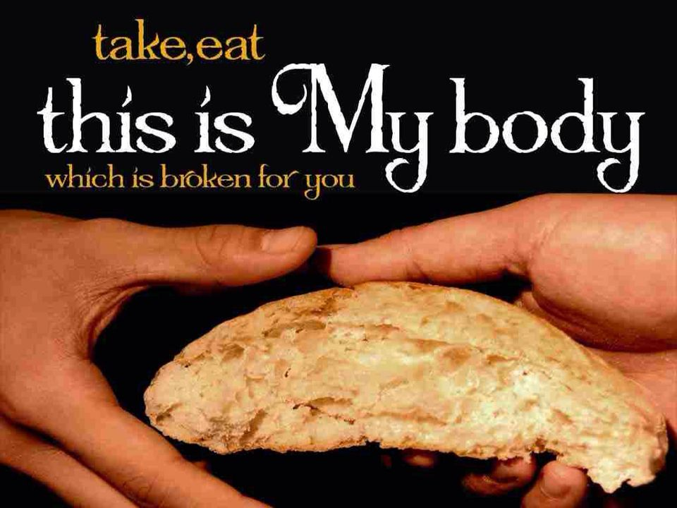

PO Box 626 925 Ford St. Lapel, IN 46051 ph: 765-534-3314
www.fordstreetchurch.com
Rev. John Randall, interim pastor
John.randall@inumc.org
Order of Worship
April 7, 2024 9:30 am

PRELUDE Cathy Boone & Linda Hormell

WELCOME Pastor John

*HYMN “Alleluia, Alleluia” Everyone

INVOCATION Pastor John

BIRTHDAYS, ANNIVERSARIES & ANNOUNCEMENTS Jim Hormell

PASSING OF THE PEACE
Greet one another with the peace of the Risen Christ!

*PRAISE SONGS Everyone
“Were You There” vs 1 & 4
“He Is Lord”
“Almighty”
“Rejoice, the Lord Is King” #715 vs 1 & 2

CHILDREN’S MESSAGE Kyndra Springer
The children may return to their seats in order to
participate in Holy Communion with their families.

CALL TO OFFERING Jim Hormell

*DOXOLOGY

*PRAYER OF OFFERING DEDICATION Pastor John

MESSAGE “Easter, Being Aware of Christ’s Presence” Pastor John
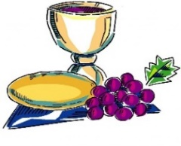

Holy Communion

*HYMN “Let Us Break Bread Together” #618 Everyone

HOLY COMMUNION LITURGY

INTRODUCTION TO PRAYER TIME Pastor John

PASTORAL PRAYER/LORD’S PRAYER Pastor John
(Unison) “Our Father, who art in heaven, hallowed be thy name. Thy kingdom come, thy will be done, on earth as it is in heaven. Give us this day our daily bread and forgive us our sins as we forgive those who sin against us. Lead us not into temptation but deliver us from evil; for thine is the kingdom and the power and the glory forever. Amen.

THE GIVING

*CLOSING HYMN “Blest Be the Tie That Binds” #557 Everyone

*SENDING Pastor John

Prayer for Ford Street Church
“Lord Jesus, prepare us, Ford Street UMC, to be a people with their arms wide open. Prepare us to be ready to fully embrace, engage and encourage one another,
a new pastor and the community. Amen.”

*POSTLUDE

